**AssetTracker Reports**

Crystal Reports can be configured and loaded into AssetTracker. Most of these reports will run off the AssetTracker database which uses the stored procedures and not the asset table. The following documentation includes special considerations that need to be made in the Crystal Report in order to run in AssetTracker as well as how to load and configure reports in AssetTracker.

**Configuring a Crystal Report for AssetTracker**

* If you have an existing Crystal Report it can be relinked to the stored procedure.
* Whether relinking an existing report or creating a new report choose the following options.
  + Create New Connection
    - OLE DB
      * Use the SQL Server Native Client 10.0 driver (if available)
      * Choose the server name, check integrated security, and pick the AssetTracker database.

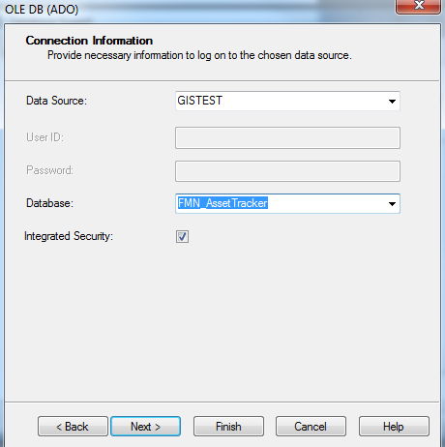

* From the database connection ->dbo -> StoredProcedures
  + Choose the table you want to add to the report. Ex. eo_GetTransformerAssetEquipement is the AssetTransformer table.
* The parameter that the report will use to run will need to be created in Crystal Reports and configured as the selection criteria.

Ex. Location parameter

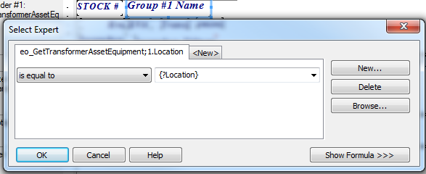

* Make sure “Save Date with Report” is not checked. Otherwise the data results will not be refreshed when the report is ran in AssetTracker.

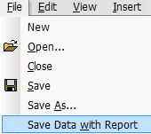

**Loading a Report in AssetTracker**

* From the Setup tab in AssetTracker the admin can see three report configuration options.

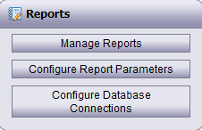

* Configure Database Connections
  + By default the LocalMachine connection will be pointing to the AssetTracker database. This is the preferred connection for running the reports because it is looking at the live data. A client may want to run a report off of a personal geodatabase if the report is using more than one table.

Ex. SDE & PDGB connection configuration:



* Configure Report Parameters
  + The field that is being used as the parameter to run the report will need to be configured here. The display name can be an alias, but the parameter name must match the exact field name. Some of the parameter types include string, date, date range, and list (domain).
    - The parameter details for a list will include all of the possible values.

Ex. Installed:Installed;Warehouse:Warehouse;Disposed:Disposed

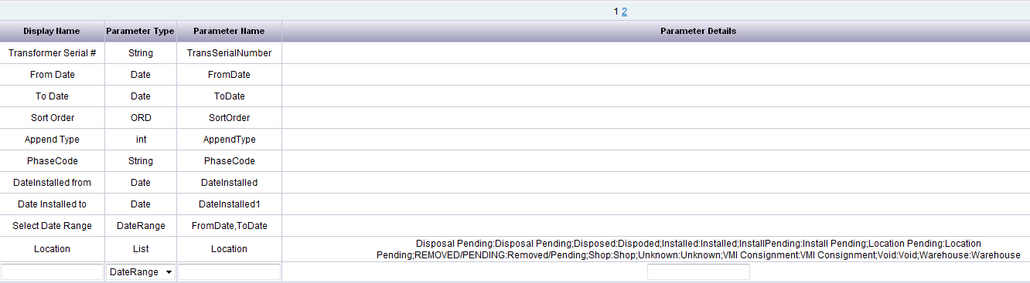

* Manage Reports
  + Choose 
    - Report Name – The report can be named anything desired.
    - File – Browse to the location of the Crystal Report that is to be loaded. Once saved it will be stored on the server …\inetpub\wwwroot\AssetTracker\Reports\
    - Database Config – Choose which database will be used to run the report. LocalMachine should be set to the AssetTracker database.
    - Parameters – Check the parameters that will be used to run the report. If multiple parameters are selected then both of them must be configured in the selection criteria of the Crystal Report.

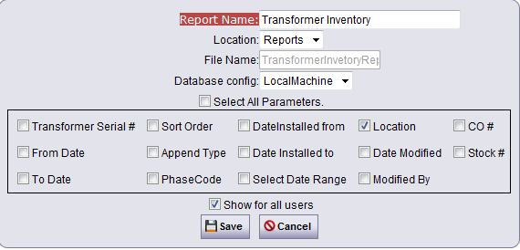

**Running Reports in AssetTracker**

* From the Reports tab select the desired report to run.
* Enter the value into the parameter field, choose from the list, or set the date depending on the parameter type.

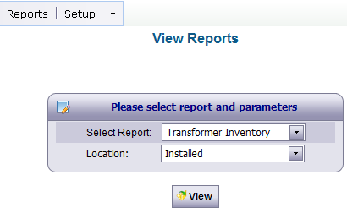

* Click View – The report will open in a separate window.

